**Sahib Nijjar**

**Reviewed by: Gunn Hwang**

**INFO 1113, S10**

**November 12, 2019**

<https://github.com/Nijjar47/Project/blob/master/FINALUSECASE.PNG>

<https://sites.google.com/view/info1112-project-2019/home>

**My Original Use Case Diagram**

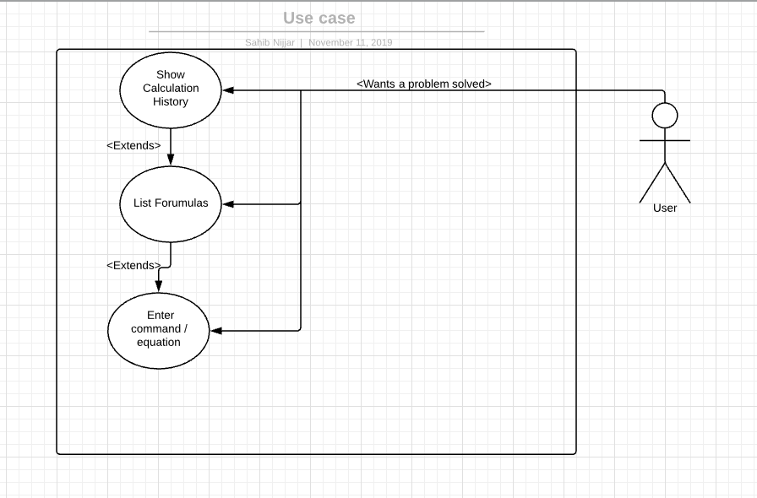

This picture above is my original use case diagram that each group member had to create. Mine consisted of 3 uses, show calculation history, list formulae, and enter command/equation.

**Final Use Case Diagram**

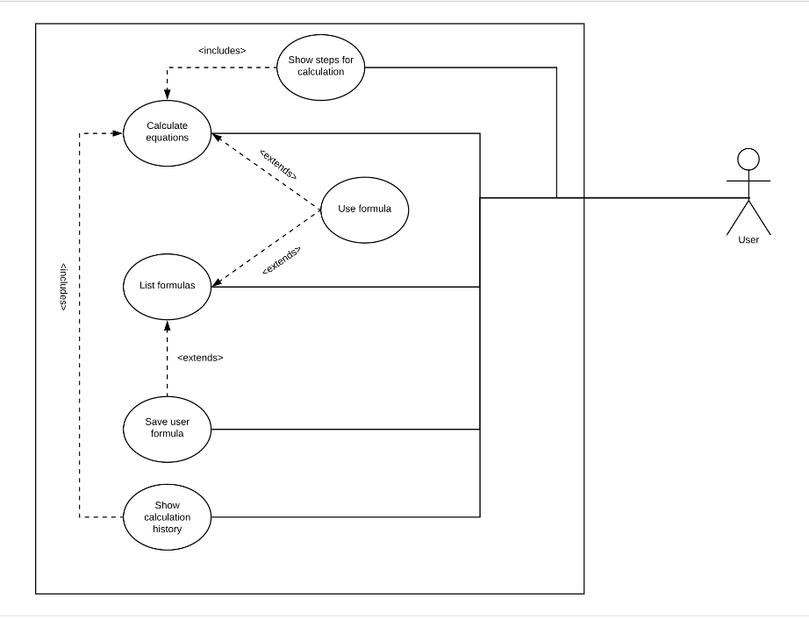

|  |
| --- |
| Use Case Title: Show Calculation History |
| Primary Actor: User |
| Level: Birds-eye view |
| Stakeholders: User |
| Precondition: User must have had calculations already done previously |
| Minimal guarantee: Error message, Returns user to the main screen |
| Success guarantee: Shows user previously used calculations |
| Trigger: User clicks corresponding button on screen |
| Main Success Scenario:   1. User previously has entered in a calculation (e.g. 2 + 4 = 6). 2. At main menu, User clicks “Show Calculation History”. 3. Program displays previously entered calculation. |
| Extensions:   1. Previous calculations could not be displayed    1. Message created that notifies the user that no calculation could be found, returns to the main screen |

|  |
| --- |
| Use Case title: List Formulas |
| Primary actor: User |
| Level: Birds-eye view |
| Stakeholders: User |
| Precondition: User has formula(s) saved from previous equations |
| Minimal Guarantee: Error Message is displayed; User is returned to the main screen |
| Success Guarantee: Displays formulas saved from previous equations |
| Trigger: User clicks “List Formulas” button on screen |
| Main success scenario:   1. User clicks “List Formulas” 2. Program lists all previously saved formulas |
| Extensions:   1. List of formulas could not be found    1. Message created that notifies user that no formulae could be found, returns to the main screen. |

|  |
| --- |
| Use Case Title: Save user formula |
| Primary Actor: User |
| Level: Sea level |
| Stakeholders: User |
| Precondition: Program is running. At main menu or while user is in the middle of entering an equation |
| Minimal Guarantee: Error message; Returns to previous state before it is triggered |
| Success Guarantee: User saves formula and has been entered into the saved files |
| Trigger: User selects “Save user formula” button on main menu, and can enter a formula he/she wishes to save or user selects “Save used formula” in the menu while entering an equation, can be saved into files. |
| Main success scenario:   1. User clicks “Save user Formula” button on main screen    1. User enters formula    2. User saves formula 2. User enters an equation    1. User clicks “Saved used formula”    2. Formula used gets saved into files |
| Extensions:   1. Formula could not be saved    1. Message created that notifies user that formula could not be saved.    2. User tries again, return to the main screen, or exits the application. 2. Formula could not be saved    1. Message created that notifies user that formula could not be saved.    2. User tries again, return to the main screen, or exits the application. |